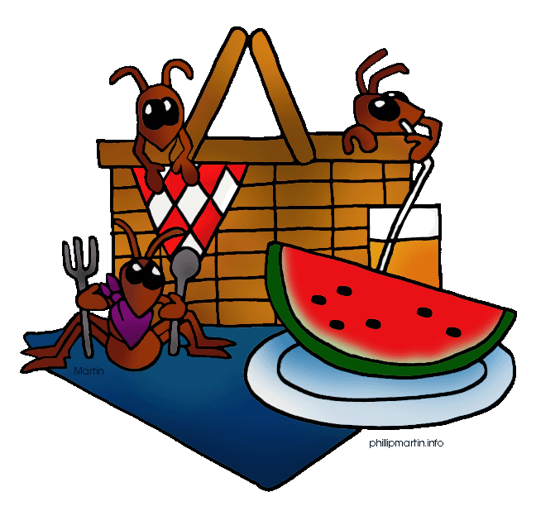

**POST-FAIR PICNIC**

**MONDAY , AUGUST 1 4th**

**6:30 P.M.**

**The Wayne Expo Center**

**MEAT WILL BE PROVIDED.**

**PLEASE BRING A SALAD, VEGGIE, OR DESSERT**

**Bring the whole family.**